WEEK 4
Supervised Learning Model Implementation
Breast Cancer Classification
Python Data Science Internship
Scikit-learn • Logistic Regression • Cross-Validation • Hyperparameter Tuning

Executive Summary
This project develops a supervised binary classification model using the public Breast Cancer Wisconsin (Diagnostic) dataset. The objective is to classify observations as malignant or benign from 30 numerical diagnostic features. Logistic Regression was selected as an interpretable and efficient baseline.
The dataset contains 569 observations and 30 features. A stratified 80/20 train-test split was used. StandardScaler and Logistic Regression were placed in a single Pipeline so preprocessing is learned only from training data. Five-fold stratified cross-validation was used for validation, followed by GridSearchCV over the regularization parameter C. The tuned model achieved 0.982 accuracy, 0.986 precision, 0.986 recall, 0.986 F1, and 0.995 ROC-AUC on the held-out test set.
The report evaluates multiple metrics, analyzes classification errors, examines permutation feature importance, and discusses strengths, limitations, and possible improvements. The results are treated as a benchmark-machine-learning exercise rather than a clinically deployable diagnostic system.

1. Problem Definition
Component | Definition
Input | 30 numerical diagnostic measurements
Target | Diagnosis
Class 0 | Malignant
Class 1 | Benign
Task | Binary classification
Model | Logistic Regression
The target is not included among the input features.

2. Dataset and Class Distribution
The Breast Cancer Wisconsin (Diagnostic) dataset is a public benchmark dataset distributed through scikit-learn. Its 30 numerical features describe measurements derived from digitized breast-mass images.
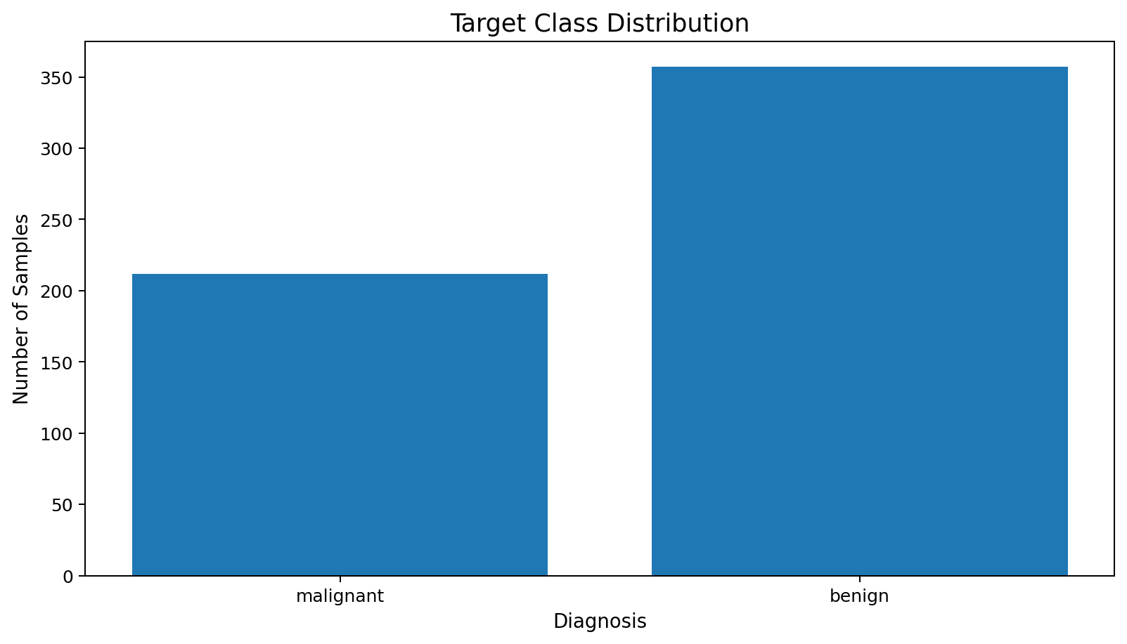
Figure 1. Distribution of malignant and benign observations.
The classes are not perfectly balanced, so stratification is used during splitting and cross-validation.

3. Data Preparation and Feature Engineering
The feature matrix contains numerical variables, making it suitable for Logistic Regression after standardization. No additional target-derived features are created. The key preprocessing operation is scaling.
pipeline = Pipeline([
("scaler", StandardScaler()),
("model", LogisticRegression(max_iter=5000))
])
Keeping scaling inside the pipeline is critical: during cross-validation, each training fold learns scaling parameters independently, preventing information from the validation fold from leaking into preprocessing.

4. Train-Test Split
The data was split into 455 training observations and 114 held-out test observations using stratification and random_state=42.
X_train, X_test, y_train, y_test = train_test_split(
X, y, test_size=0.20, random_state=42, stratify=y
)

5. Model Rationale
Logistic Regression was selected because this is a binary classification problem and the model provides a strong, interpretable baseline. It also produces probabilities, enabling ROC analysis and threshold-based decision making.
pipeline.fit(X_train, y_train)
pred = pipeline.predict(X_test)
prob = pipeline.predict_proba(X_test)[:, 1]

6. Cross-Validation
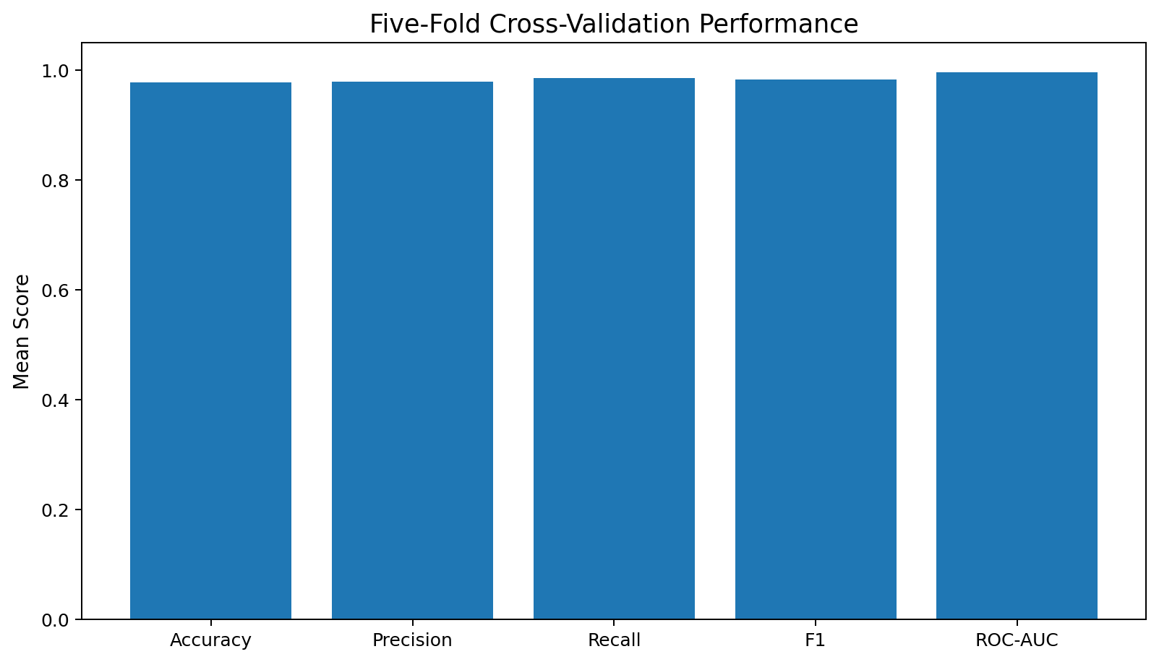
Figure 2. Mean five-fold stratified cross-validation scores.
Metric | Mean CV Score
ACCURACY | 0.978
PRECISION | 0.979
RECALL | 0.986
F1 | 0.983
ROC_AUC | 0.996
Five-fold StratifiedKFold was used to preserve class proportions. Cross-validation is performed on the training set, while the test set remains untouched until final evaluation.

7. Hyperparameter Tuning
GridSearchCV tested C values of 0.01, 0.1, 1, 10, and 100 using five-fold cross-validation and ROC-AUC as the selection metric. The best value was C=1. The search was restricted to the training data.
grid = GridSearchCV(
pipeline,
{"model__C": [0.01, 0.1, 1, 10, 100]},
cv=cv, scoring="roc_auc"
)
grid.fit(X_train, y_train)

8. Final Model Evaluation
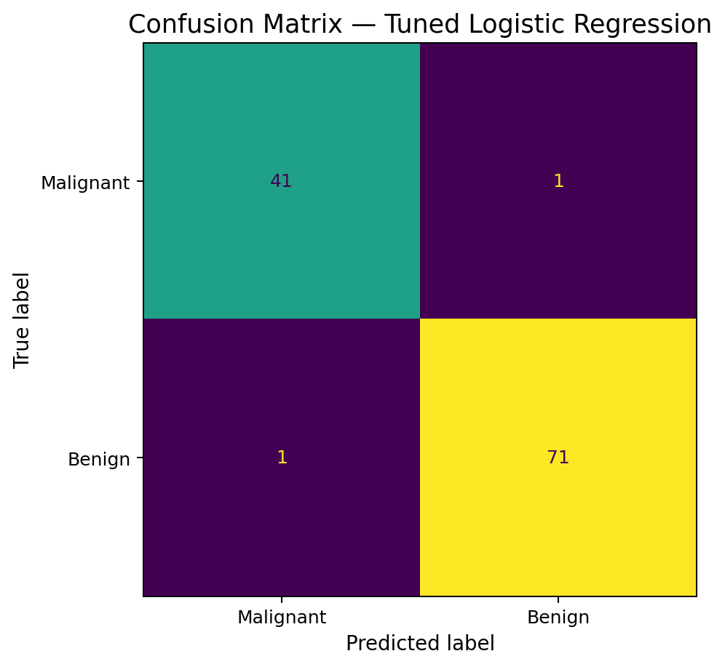
Figure 3. Confusion matrix for the tuned Logistic Regression model.
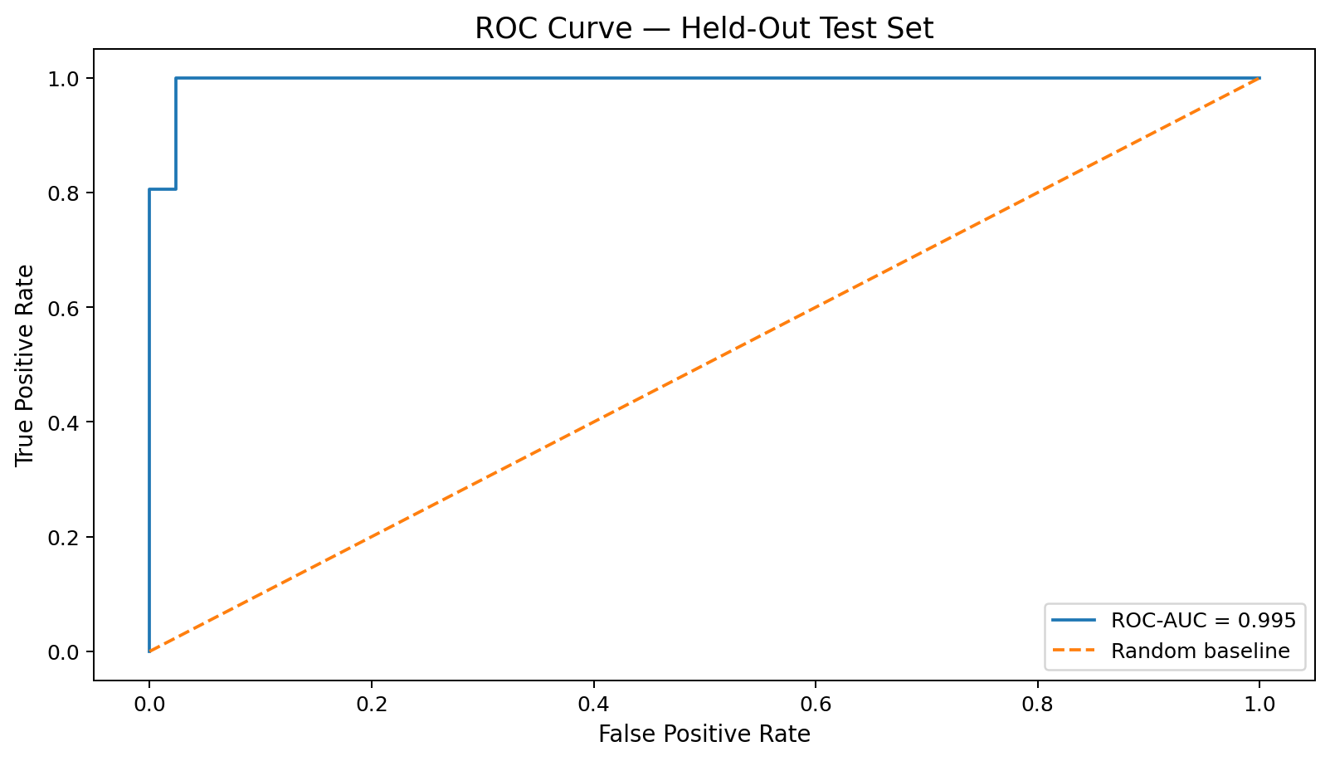
Figure 4. ROC curve on the held-out test set.
Metric | Baseline | Tuned
Accuracy | 0.982 | 0.982
Precision | 0.986 | 0.986
Recall | 0.986 | 0.986
F1 | 0.986 | 0.986
ROC-AUC | 0.995 | 0.995
The tuned model achieved 98.6% recall and 0.995 ROC-AUC on the held-out test set. The confusion matrix contains TN=41, FP=1, FN=1, and TP=71, using malignant as class 0 and benign as class 1.
Accuracy alone is insufficient when different classification errors have different consequences. In a real diagnostic setting, the decision threshold and error costs would require domain-specific evaluation.

9. Feature Importance
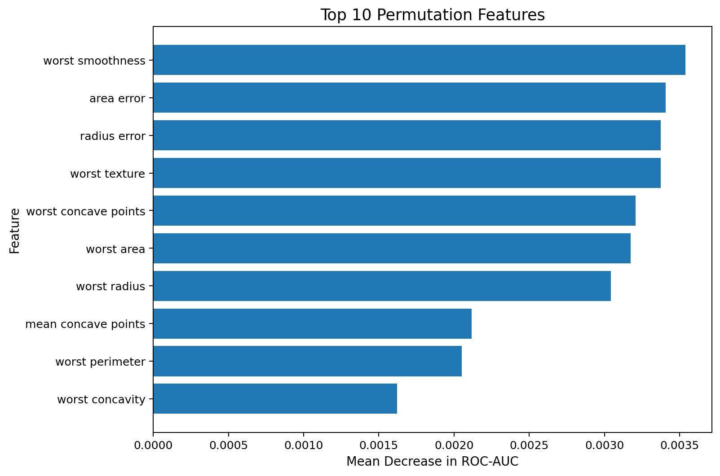
Figure 5. Top ten features by permutation importance on the held-out test set.
Permutation importance measures the change in test ROC-AUC after randomly shuffling a feature. It is an interpretive diagnostic, not evidence of causation. Correlated features may share predictive information.
- worst smoothness: mean ROC-AUC decrease 0.0035
- area error: mean ROC-AUC decrease 0.0034
- radius error: mean ROC-AUC decrease 0.0034
- worst texture: mean ROC-AUC decrease 0.0034
- worst concave points: mean ROC-AUC decrease 0.0032

10. Baseline vs Tuned Model
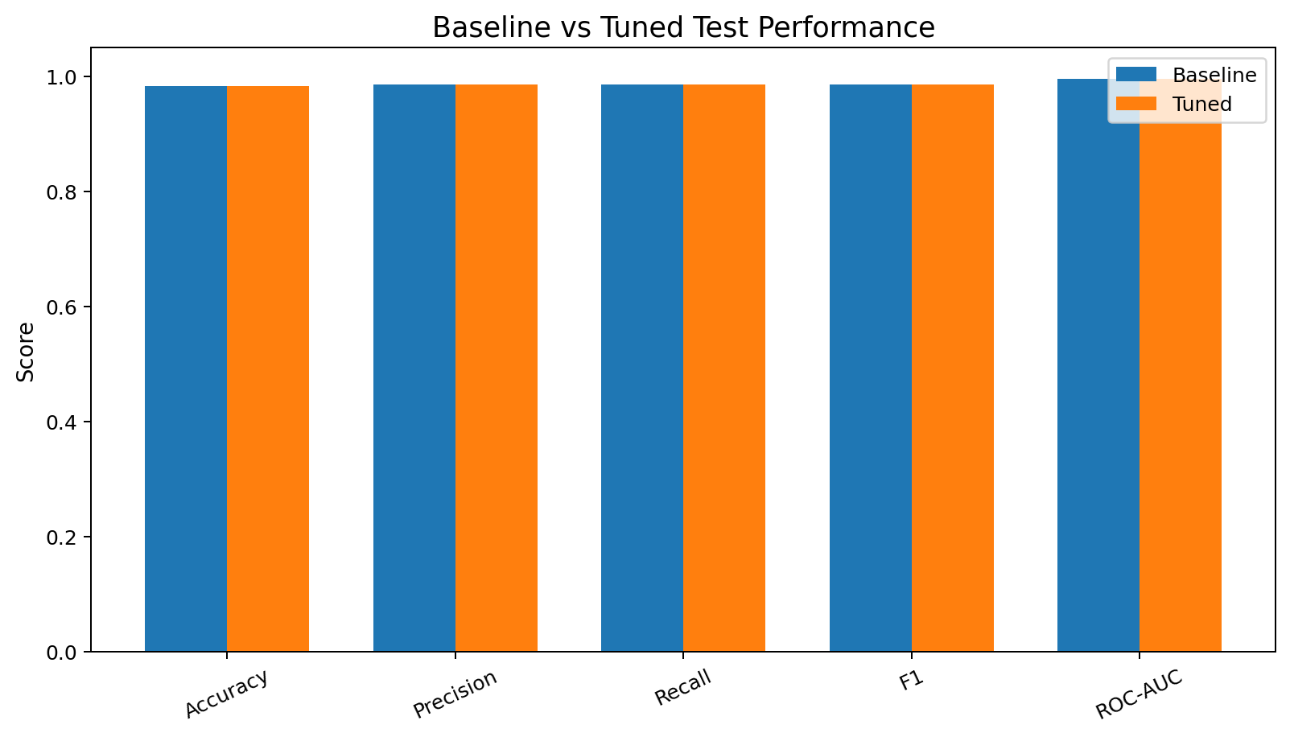
Figure 6. Baseline versus tuned test-set performance.
The tuning step evaluates whether changing regularization improves held-out performance. The relatively simple model is intentional: increased complexity is not automatically an improvement unless it produces more reliable generalization.

11. Strengths
- Clear binary classification objective.
- Stratified and reproducible train-test split.
- Pipeline-based preprocessing prevents leakage.
- Five-fold cross-validation.
- Hyperparameter tuning restricted to training data.
- Multiple evaluation metrics.
- Confusion matrix and ROC analysis.
- Permutation feature-importance analysis.

12. Limitations and Improvements
- The dataset is a benchmark and should not be treated as evidence for clinical deployment.
- Logistic Regression models a linear decision boundary in the transformed feature space.
- Threshold selection could be optimized for specific error costs.
- Random Forest, SVM, or Gradient Boosting could be compared under identical cross-validation.
- Nested cross-validation would provide a more rigorous estimate during extensive model comparison.
- Feature selection or dimensionality reduction could address redundancy among correlated measurements.
- Independent external validation would be necessary before making generalization claims.

13. Reproducibility
The project package contains the complete Python script, dataset export, held-out predictions, six figures, and this report.
# Week 4: Supervised Learning Model Implementation
from sklearn.datasets import load_breast_cancer
from sklearn.model_selection import train_test_split, StratifiedKFold, cross_validate, GridSearchCV
from sklearn.pipeline import Pipeline
from sklearn.preprocessing import StandardScaler
from sklearn.linear_model import LogisticRegression
from sklearn.metrics import accuracy_score, precision_score, recall_score, f1_score, roc_auc_score
data = load_breast_cancer(as_frame=True)
X = data.data
y = data.target
X_train, X_test, y_train, y_test = train_test_split(
X, y, test_size=0.20, random_state=42, stratify=y
)
pipeline = Pipeline([
("scaler", StandardScaler()),
("model", LogisticRegression(max_iter=5000, random_state=42))
])
cv = StratifiedKFold(n_splits=5, shuffle=True, random_state=42)
cv_results = cross_validate(
pipeline, X_train, y_train, cv=cv,
scoring=["accuracy", "precision", "recall", "f1", "roc_auc"]
)
pipeline.fit(X_train, y_train)
pred = pipeline.predict(X_test)
prob = pipeline.predict_proba(X_test)[:, 1]
print("Test ROC-AUC:", roc_auc_score(y_test, prob))
grid = GridSearchCV(
pipeline,
{"model__C": [0.01, 0.1, 1, 10, 100]},
cv=cv, scoring="roc_auc"
)
grid.fit(X_train, y_train)
print("Best C:", grid.best_params_)
best_model = grid.best_estimator_
pred = best_model.predict(X_test)
prob = best_model.predict_proba(X_test)[:, 1]
print("Accuracy:", accuracy_score(y_test, pred))
print("Precision:", precision_score(y_test, pred))
print("Recall:", recall_score(y_test, pred))
print("F1:", f1_score(y_test, pred))
print("ROC-AUC:", roc_auc_score(y_test, prob))

14. Conclusion
This project demonstrates a complete supervised-learning pipeline from problem definition and preprocessing through model training, cross-validation, hyperparameter tuning, and final evaluation. The tuned Logistic Regression model achieved 0.995 ROC-AUC on the held-out test set. The main methodological lesson is that preprocessing and model selection must be isolated from the test data to avoid leakage. The results are strong for this benchmark dataset, while the documented limitations show why benchmark performance should not be confused with real-world clinical readiness.

Appendix — Complete Python Script
# Week 4: Supervised Learning Model Implementation
from sklearn.datasets import load_breast_cancer
from sklearn.model_selection import train_test_split, StratifiedKFold, cross_validate, GridSearchCV
from sklearn.pipeline import Pipeline
from sklearn.preprocessing import StandardScaler
from sklearn.linear_model import LogisticRegression
from sklearn.metrics import accuracy_score, precision_score, recall_score, f1_score, roc_auc_score
data = load_breast_cancer(as_frame=True)
X = data.data
y = data.target
X_train, X_test, y_train, y_test = train_test_split(
X, y, test_size=0.20, random_state=42, stratify=y
)
pipeline = Pipeline([
("scaler", StandardScaler()),
("model", LogisticRegression(max_iter=5000, random_state=42))
])
cv = StratifiedKFold(n_splits=5, shuffle=True, random_state=42)
cv_results = cross_validate(
pipeline, X_train, y_train, cv=cv,
scoring=["accuracy", "precision", "recall", "f1", "roc_auc"]
)
pipeline.fit(X_train, y_train)
pred = pipeline.predict(X_test)
prob = pipeline.predict_proba(X_test)[:, 1]
print("Test ROC-AUC:", roc_auc_score(y_test, prob))
grid = GridSearchCV(
pipeline,
{"model__C": [0.01, 0.1, 1, 10, 100]},
cv=cv, scoring="roc_auc"
)
grid.fit(X_train, y_train)
print("Best C:", grid.best_params_)
best_model = grid.best_estimator_
pred = best_model.predict(X_test)
prob = best_model.predict_proba(X_test)[:, 1]
print("Accuracy:", accuracy_score(y_test, pred))
print("Precision:", precision_score(y_test, pred))
print("Recall:", recall_score(y_test, pred))
print("F1:", f1_score(y_test, pred))
print("ROC-AUC:", roc_auc_score(y_test, prob))

